FaceRepulsion – behavioral pilot

**Goal**

Find appropriate study design and appropriate stimuli such that the stimuli are sufficiently learned and positioned on the *verge* of eliciting high-confidence discrimination & behavioral repulsion bias.

Design / Procedure

**Experiment broken into 15 blocks, each block consists of 3 tasks (in order):**

**(1) Study Phase (2) AFC (3) Face Report**

**Each block is independent from the other blocks in terms of the stimuli to be memorized & tested.**

Experiment duration = approx. 39 minutes

Study Phase: 3.4s x (8 + 16 + 24) = 163s = 2.7 min per block * 5 blocks = 13.5 min

AFC: (2.4s + 3s response) * 8 * 15 = 648s = 10.8 min

Face Report: (2.4s + 5s response) * 8 * 15 = 888s = 14.8 min

**STUDY PHASE**

Task: Memorize the faces and their associated images (scene/object)

Each face will have a similar-looking face that will appear in the same block (these two faces collectively referred to as a face-pair). Face As of the face-pair will be paired with a unique scene, and Face Bs will be paired with a unique object.

Stimuli in each block randomly distributed across the study phase, with the exception that all stimuli need to have been shown at least once before a stimulus is repeated within the block.

Design: 1s face, 200ms blank, 1s scene/object, 1200ms blank

(same trial design as the study phase in Wanjia et al. (2021))

Randomly interleaved across the 15 blocks, 5 of the blocks will have Design 1, 5 will have Design 2, and 5 will have Design 3. Total of 60 different face pairs tested (so 120 unique faces studied).

Design 1: 4 face-pairs (total of 8 faces), only shown one time each

Design 2: 4 face-pairs (total of 8 faces), each repeated once

Design 3: 4 face-pairs (total of 8 faces), each repeated twice

---

Note that Wanjia et al. (2021) used a similar experimental design and observed an “inflection point” (the point at which AFC discrimination transitioned from low- to high-confidence correct retrieval for both associates within a pairmate) typically during the second “round” (somewhat akin to Design 2 in the current proposed design). However, they used 36 pair-mates all learned at the same time across the entirely of the experiment. They did not quantify similarity for their highly similar pairs or do anything special to ensure that the pairmates were roughly of the same perceptual dissimilarity. E.g., two similar objects and two similar scenes that composed pairs in their study (https://osf.io/vpq2x/):

**ALTERNATIVE FORCED CHOICE (AFC)**

Task: Select the presented face’s associated image

Design: 1s face, 200ms blank, wait until response, 1200ms blank

For the two images presented as choices, one will be the correct associate while the other image will be the associate for the paired face (i.e., the wrong choice).

*Note: I’m still unsure if we should swap this so that it’s the scene/object presented first with the subject then determining which face is correct*

**FACE REPORT**

Task: Recreate the face associated with the presented image by adjusting the slider

Design: 1s associate, 200ms blank, wait until response, 1200ms blank

Planned analysis

The 3 within-subject design “conditions” vary in terms of the number of stimulus repetitions. More repetitions should mean more robust memories (and their associates) are learned. **We want there to be a design that shows high-confidence correct discrimination *and* behavioral repulsion and then use the design that has one less repetition (a design that is not already showing repulsion), likely meaning subject is on the verge of such repulsion.**

**Desired hypothetical results**

The below hypothetical results would suggest that we could use Design 1 to elicit memory behavior that is on-the-verge of repulsion. The dotted horizontal line shows the average behavior after the 2nd round for Wanjia et al. (2021). Also, as reference, Chanales et al. (2021) used a simultaneous study design and observed significant repulsion for high-similarity pairs given a discrimination accuracy of around 90% in Expt 1 and around 85% in Expt 2.

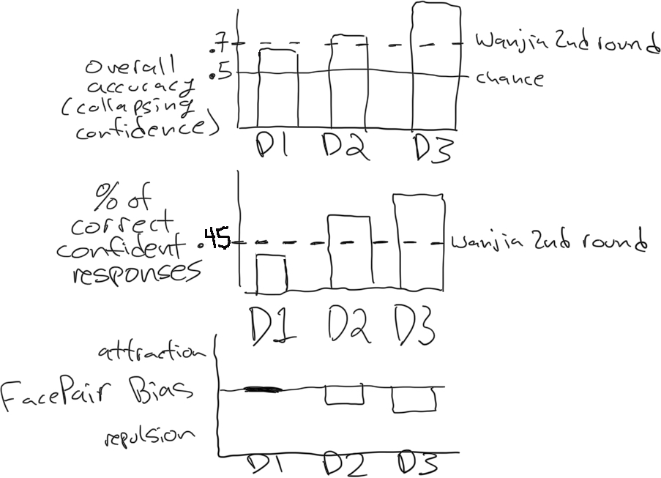

**Face Dissimilarity**

Not all stimuli are created equal, and it is difficult to measure face-pair dissimilarity. Hence, there will be some face-pair stimuli that are more perceptually different than other face-pair stimuli, and this likely will influence whether repulsion is observed. If needed, we can run several iterations of this experiment where the locations of Face A and Face B along their respective face-axis is refined across iterations.

Example

Not depicted: likewise, if some face-pairs appear more difficult to memorize compared to the other face-pairs, we can sample A and B farther apart from each other along their face-axis. If some face-pairs appear to be outliers according to the behavioral data, we can entirely replace them or discard them.

Idea is that by iteratively fine-tuning where we sample face A and face B along each face-axis, we can identify a collection of face-pairs that will be well-suited for the eventual repulsion experiment. If this behavior is mostly consistent across face-pairs, it doesn’t really matter if we have a valid measure of perceptual dissimilarity (i.e., this is a way to get around having to collect/analyze a preliminary pilot experiment where we collect perceptual dissimilarity measurements or needing to rely on the AlexNet intermediate layers [LPIPS] method for determining perceptual dissimilarity).

Sample size & recruitment plan

Sample size: 50 MTurk participants (per experiment iteration)

Rationale: Sample size is difficult to calculate a priori. Wanjia et al. (2021) was a long-term memory neuroimaging experiment with a similar experimental design that included 36 participants and observed significant CA3/DG separation correlated with high-confidence discrimination. Chanales et al. (2021) observed behavioral repulsion bias in long-term memory using between 23-36 in-lab subjects per experiment. In working memory literature, Scotti et al. (2021) observed robust behavioral mnemonic repulsion bias with 50 MTurk subjects.

Stimulus set

Object stimuli come from the “Massive Memory” Unique Object Imageset (Brady, Konkle, Alvarez, & Oliva, 2008)

Scene stimuli come from the “Massive Memory” Scene Categories Imagset (Konkle, Brady, Alvarez, Oliva, 2012)

Face stimuli are synthesized from StyleGAN-XL using the pretrained FFHQ 256x256 model (<https://github.com/autonomousvision/stylegan_xl>).

All the interpolated faces can be seen here: <https://github.com/PaulScotti/paulscotti.github.io/tree/master/mturk/interpfaces>